DIP SLIPS

1. A) grey level slicing with and without background

Grey level slicing is a simple image processing technique used to highlight specific areas in an image based on their grey levels. The technique is particularly useful when you want to isolate or enhance specific objects or regions in an image.

When performing grey level slicing without a background, the objective is to create a binary image where the pixels within a specific range of grey levels are set to one and all other pixels are set to zero.The basic steps involved in grey level slicing without background are as follows:

Choose the range of grey levels to be sliced. For instance, if the image has 8-bit grey levels ranging from 0 to 255, you can select a range such as 100 to 200.

Threshold the image using the chosen grey level range. Pixels with grey levels within the range are set to one, and all other pixels are set to zero. This creates a binary image that highlights the region of interest.

Further image processing operations such as morphological operations or filtering can be applied to refine the binary image to get the desired result.

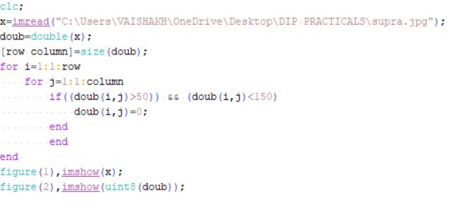

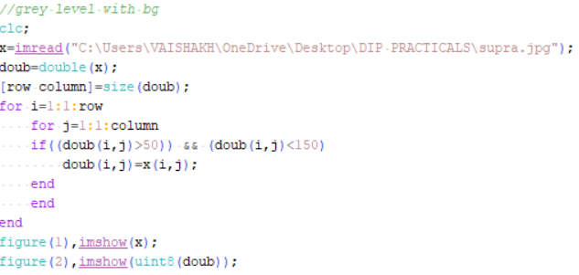

b) obtain image negative and threshold of image

In image processing, the negative of an image is a transformation that produces a new image with the same size and shape as the original, but with the intensity values inverted. That is, the darkest pixels in the original image become the brightest in the negative, and vice versa.

Thresholding is a technique used in image processing to convert a grayscale or color image into a binary image. A binary image is an image where each pixel has one of two possible values: 0 or 1. In thresholding, a pixel in the input image is compared to a threshold value. If the pixel value is higher than the threshold, it is assigned the value 1, and if it is lower than the threshold, it is assigned the value 0.

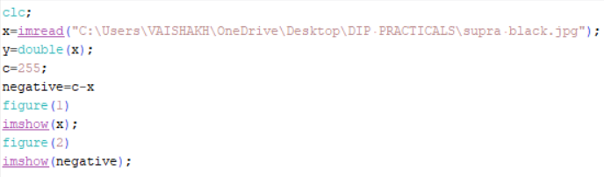

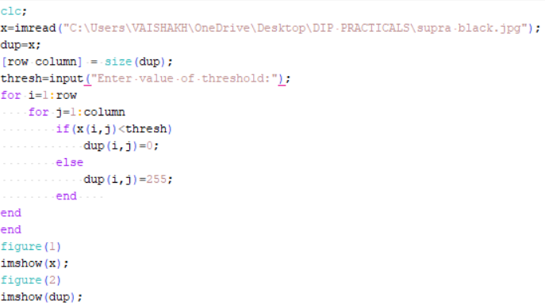

1. A) Gaussian IPF on an input image and write conclusion

In Scilab, the **mesh()** function is used to create a three-dimensional surface plot of a mathematical function or a set of data points.

Gaussian Image Pyramid (Gaussian IPF) is a technique used in image processing to decompose an image into multiple levels of resolution, where each level represents a different scale of the image. It is based on the concept of a Gaussian filter, which is a low-pass filter that attenuates high-frequency components of an image while preserving its low-frequency components.

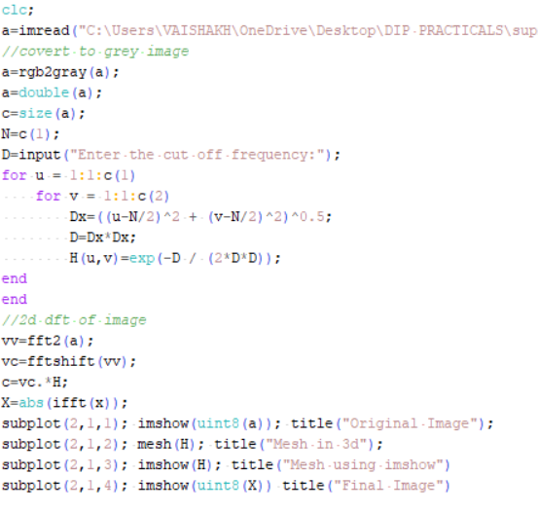

b) Perform dilation and erosion to an input image and write conclusion.

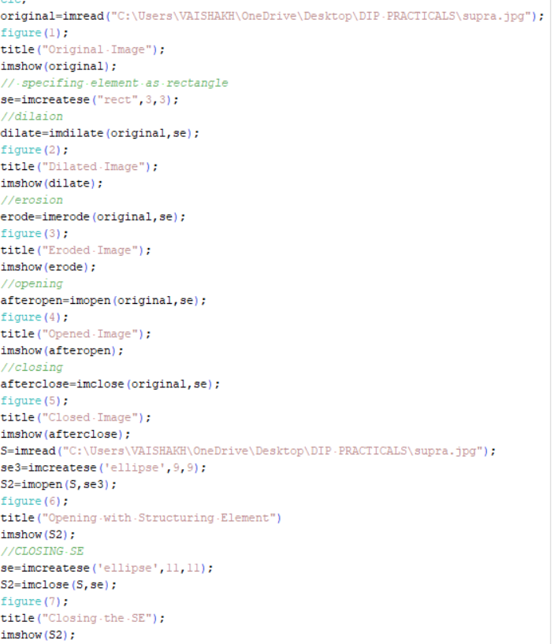

1. Circular Convolution and sum using Matrix method .

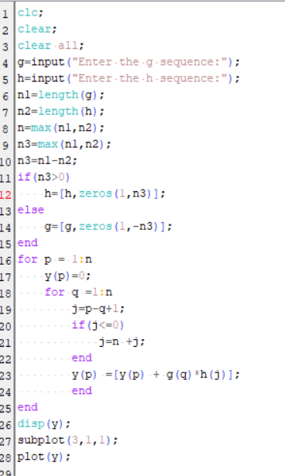

Circular convolution is also known as cyclic convolution is a special case of periodic convolution which is the convolution which is convolution of two periodic functions that have the same period. Two methods are concentric circle method and matrix multiplication method.

Circular convolution is also used in the implementation of circular shifting or rotation of images, as well as in the computation of correlation between two images. Correlation involves finding the similarity between two images by convolving one image with a flipped version of the other image.

1. Linear Convolution and sum of Circular convolution using DFT and IDFT.

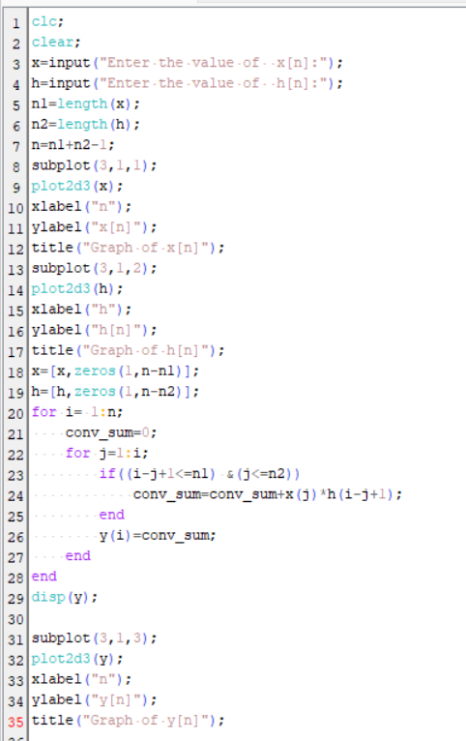

Linear convolution is a mathematical operation used to combine two signals or sequences to generate a third signal or sequence that represents the way the two signals interact with each other over time.

In other words, it is a way of finding the relationship between two input signals by measuring their overlap at every point in time.

One of the main reasons is that it provides a way to filter or enhance images.

1. DFT AND IDFT and exponentially increasing signal

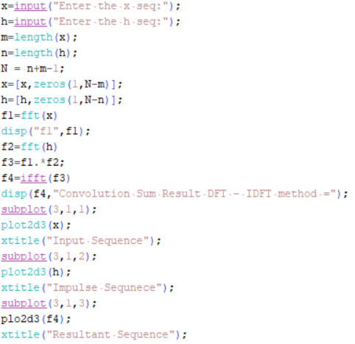

In image processing, the Discrete Fourier Transform (DFT) and the Inverse Discrete Fourier Transform (IDFT) are mathematical techniques used to transform an image from the spatial domain to the frequency domain and back again.

The DFT is used to analyze the frequency content of an image by transforming the image from the spatial domain (pixel values) to the frequency domain (amplitude and phase information). The DFT is computed by breaking the image down into a set of sine and cosine waves with different frequencies and amplitudes, which can be used to analyze the image's frequency content.

The IDFT, on the other hand, is used to transform an image from the frequency domain back to the spatial domain. The IDFT takes the amplitude and phase information from the frequency domain and reconstructs the original image in the spatial domain.

1. BITPLANE SLICING

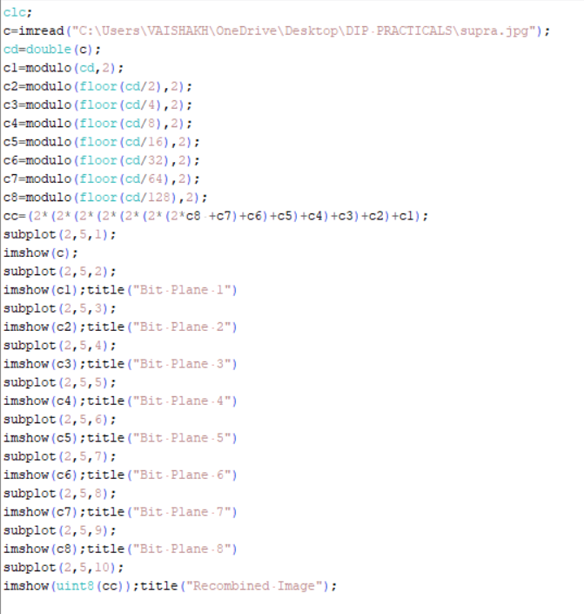

Bitplane slicing is a technique used in digital image processing to extract the bit planes of an image. In a digital image, each pixel is represented by a binary code that specifies the intensity or color of the pixel. The bitplane slicing technique involves separating the binary codes into their individual bit planes, where each bit plane represents the contribution of a particular bit to the overall intensity or color of the pixel.

1. GAUSSIAN



Gaussian Image Pyramid (Gaussian IPF) is a technique used in image processing to decompose an image into multiple levels of resolution, where each level represents a different scale of the image. It is based on the concept of a Gaussian filter, which is a low-pass filter that attenuates high-frequency components of an image while preserving its low-frequency components.

1. PREWITT,SOBEL AND BUTTERWORTH

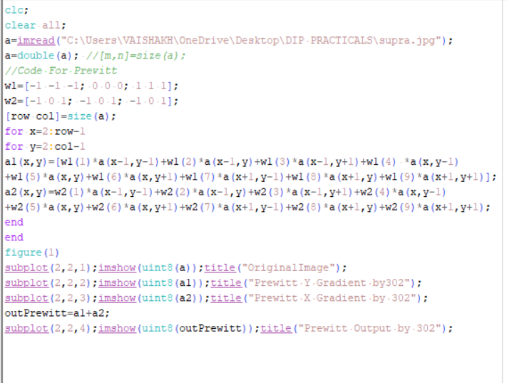

The Prewitt operator is a simple and computationally efficient method for edge detection, but it can produce noisy results in some cases. It is often used as a basic edge detection technique, but more sophisticated methods may be needed for certain applications.

Prewitt is an edge detection operator in image processing that is used to detect edges in digital images. The Prewitt operator works by calculating the gradient of the image intensity at each pixel, using a 3x3 filter kernel.

The Sobel operator is a commonly used edge detection filter in image processing. Like the Prewitt operator, it approximates the gradient of the image intensity function to detect edges.

To apply the Sobel operator to an image, the filter kernel is moved across the image, and at each pixel, the convolution of the filter kernel with the corresponding pixels in the image is calculated. This produces two new images, one for the horizontal edges and one for the vertical edges.

Butterworth filter is a type of digital filter used in image processing to remove unwanted frequency components from an image. It is a low-pass filter that attenuates high-frequency components of an image while allowing low-frequency components to pass through the filter.

Butterworth filters are commonly used in image processing for applications such as image smoothing, noise reduction, and image restoration.

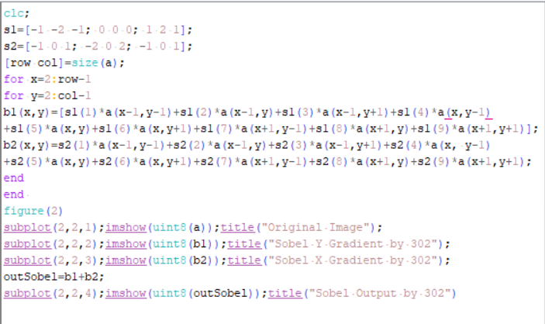

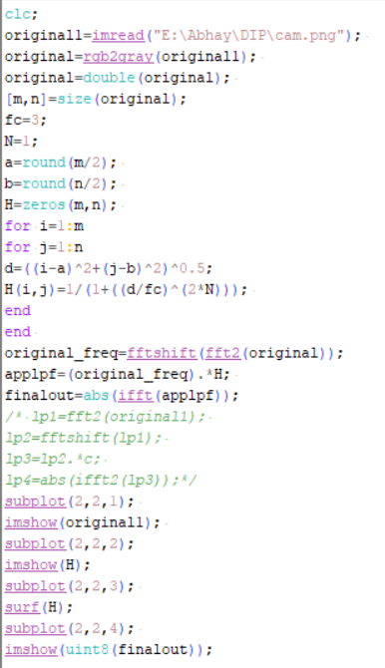

IPF,HPF

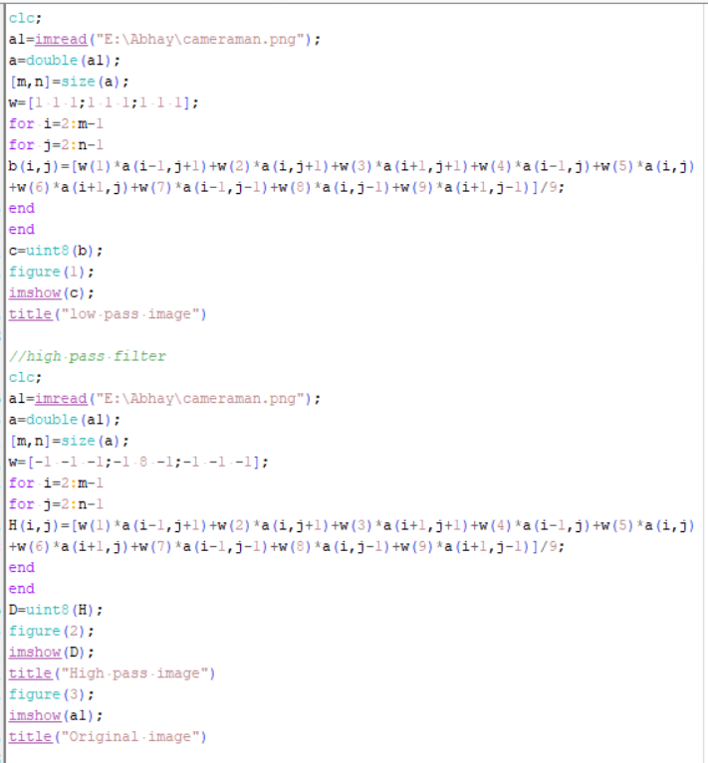

A low-pass filter is a filter that allows low-frequency components of an image to pass through the filter while attenuating high-frequency components. This type of filter is often used for image smoothing, noise reduction, and blurring. A low-pass filter can help remove high-frequency noise or fine details from an image while preserving the overall structure and shape of the image.

A high-pass filter, on the other hand, is a filter that allows high-frequency components of an image to pass through the filter while attenuating low-frequency components. This type of filter is often used for edge detection, sharpening, and enhancing high-frequency features in an image. A high-pass filter can help enhance the edges and details in an image while reducing the overall smoothness and blurriness of the image.

1. IMAGE QUANTIZTION

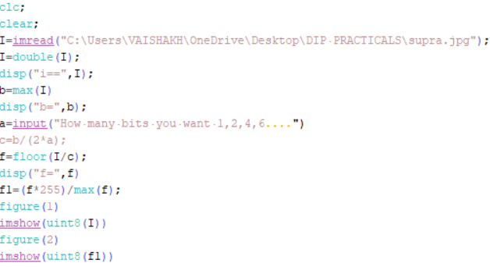

Quantization is opposite to sampling. It is done on Y axis. When you are quantizing an image you are actually divide a signal into partitions.On the x axis of the signal, are the coordinate values and on the y axis we have amplitudes so, digitizing the amplitudes is known as quantizing.

1. Bit Resolution

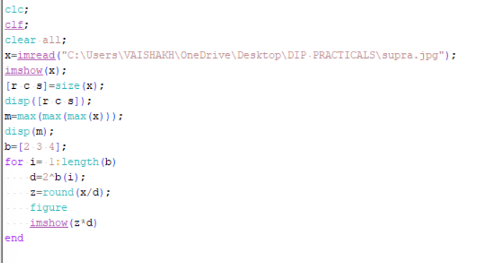

Bit pixels are capable of displaying and color value black and white.8 bit pixels can display one of 256 color values(2^8). 16 bit displays more than 65000 colors. 24bit displays more than 16 million colors.Higher bit resolutions allow for more detail to be captured in the image, resulting in higher image quality, but require more storage space and computational resources to process.

**Practical 13 (Edge Detection)**

**Code for *Edge Detection using Ordinary operator*:**

a=imread("E:\Abhay\DIP\cam.png");

a=rgb2gray(a);

a=double(a);

[row col]=size(a);

w1=[1 0; -1 0];

w2=[1 -1; 0 0];

for x=2:1:row-1

for y=2:1:col-1

a1(x,y)=w1(1)*a(x,y) +w1(2)*a(x,y+1) +w1(3)*a(x+1,y) +w1(4)*a(x+1,y+1);

a2(x,y)=w2(1)*a(x,y) +w2(2)*a(x,y+1) +w2(3)*a(x+1,y) +w2(4)*a(x+1,y+1);

end

end

a3=a1+a2;

subplot(2,2,1);imshow(uint8(a1))

title('X-gradient image')

subplot(2,2,2);imshow(uint8(a2))

title('Y-gradient image')

subplot(2,2,3);imshow(uint8(a3))

title('Resultant gradient image')

//Edge Detection using Roberts operator:

clc;

a=imread("E:\Abhay\DIP\cam.png");

a=rgb2gray(a);a=double(a);

w1=[1 0; 0 -1];

w2=[0 1;-1 0];

for x=2:1:row-1

for y=2:1:col-1

a1(x,y)=w1(1)*a(x,y) +w1(2)*a(x,y+1) +w1(3)*a(x+1,y) +w1(4)*a(x+1,y+1);

a2(x,y)=w2(1)*a(x,y) +w2(2)*a(x,y+1) +w2(3)*a(x+1,y) +w2(4)*a(x+1,y+1);

end

end

a3=a1+a2;

subplot(2,2,1);imshow(uint8(a))

title('Original image')

subplot(2,2,2);imshow(uint8(a1))

title('X-gradient image')

subplot(2,2,3);imshow(uint8(a2))

title('Y-gradient image')

subplot(2,2,4);,imshow(uint8(a3))

title('Resultant gradient image')